**Probability Solutions**

**Questions 1-3 relate to the** situation where we are picking cards at random from a regular set of 52 playing cards.

**1.** What is the probability of picking a 7? There are four 7s in the pack of 52, therefore prob(7) = 4/52 = 1/13

**2.** What is the probability of picking a heart? There are 13 hearts in the pack of 52, therefore prob(heart) = 13/52 = 1/4

**3.** What is the probability of picking a 7 given that it is a heart? Suppose that we pick a heart … what then is the probability that we’ve picked a 7 … there is one 7 in amongst the 13 hearts, therefore prob(7 | heart) = 1/13

**Questions 4-7 refer to the following situation:** Suppose now that we remove permanently from the pack the 3 and 4 of spades, the 6 of hearts and the 9 of clubs.

**4.** What is the probability of picking a 7? There are four 7s in the pack of 48, therefore prob(7) = 4/48 = 1/12

**5.** What is the probability of picking a heart? There are 12 hearts in the pack of 48, therefore prob(heart) = 12/48 = 1/4

**6.** What is the probability of picking a 7 given that it is a heart? Suppose that we pick a heart … what then is the probability that we’ve picked a 7 … there is one 7 in amongst the 12 hearts, therefore prob(7 | heart) = 1/12

**7.** Are the events “pick a 7” and “pick a heart” independent? Yes, because

prob(7) = prob(7 | heart)

**8.** Draw a Gaussian distibution function with mean -2 and variance 2. If you draw a sample from this distribution, what is the most likely value

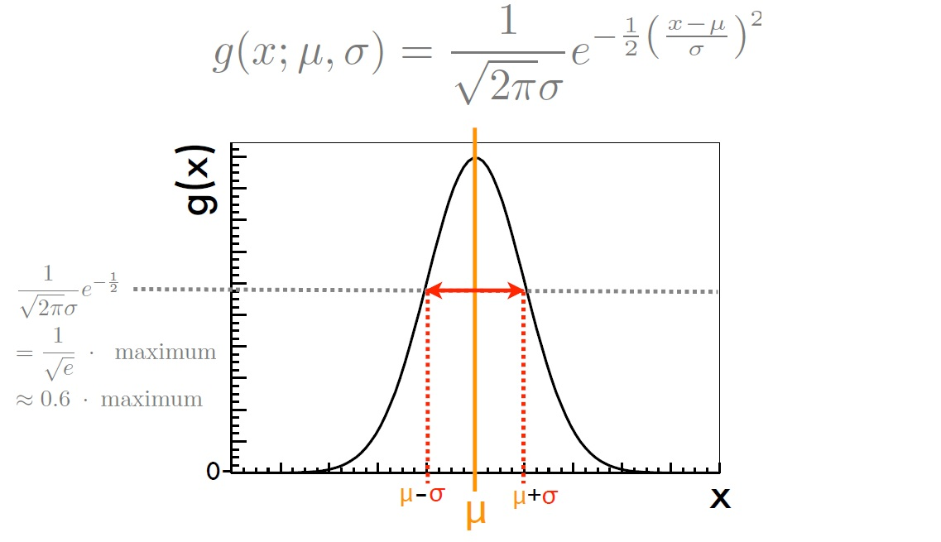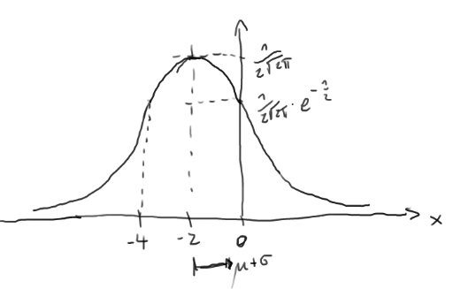

All events have zero probability, but if we allow for a small erro, values around -2 will be most likely

**9.** Assume you draw a dice 6 times and get 2, 3, 4, 1, 2, 3. What are the empirical mean, standard deviation and variance of this sample?

Mean = (2 + 3 + 4 + 1 + 2 + 3)/6 = 15/6 = 2.5

Variance = sum_i (x_i-mean)^2

Standard deviation = sqrt(variance)

**10.** If you throw a dice more and more often, what will the mean of the numbers you see converge to? And what the standard deviation?

Mean = 3.5

Standard deviation = sqrt( sum_i (i-3.5)^2 ) ~ 1/sqrt(N)

**11.** How many elements are in the set A={ x | x in N and x is odd and X is smaller than 50}

The odd number smaller than 50 = 25

**12.** What is the probability that if you choose 5 students out of 100 that they are all female? Assume that there are as many male as female students. What is the probability that their birthday falls on the same day?

Left as an exercise …